**Automation Set-up:**

You'll need to raise requests for these tools/apps on Optum AppStorementioned below:

<https://optum.service-now.com/euts_intake?id=appstore&q=jdk>.

Once the request is approved, you can install the app from the Self-Service app, which should be already installed on your device.

1. GitHub Desktop
   1. Once you get the access, to login use the sso link provided in onboarding email ([https://github.com/enterprises/uhg/sso](https://nam02.safelinks.protection.outlook.com/?url=https%3A%2F%2Fgithub.com%2Fenterprises%2Fuhg%2Fsso&data=05%7C02%7Ckumar.samrat%40publicissapient.com%7C4a88f19a3f0e43f82b6c08dd7f32596d%7Cd52c9ea17c2147b182a333a74b1f74b8%7C0%7C0%7C638806576428442668%7CUnknown%7CTWFpbGZsb3d8eyJFbXB0eU1hcGkiOnRydWUsIlYiOiIwLjAuMDAwMCIsIlAiOiJXaW4zMiIsIkFOIjoiTWFpbCIsIldUIjoyfQ%3D%3D%7C0%7C%7C%7C&sdata=QQNAgS4dzDJRSXp1r1XZNn30gZTXZ62gKuopo%2F92czE%3D&reserved=0)).
2. VSCode (Microsoft Visual Studio Code 1.97.2)  
     
     
    To get the access to the application mentioned in point 2. You need to add certain groups by following the steps (Steps and roles given are followed for a web developer role for AEM access, please confirm the access groups from your respective manager for remaining apps):
   1. Open [Secure](https://nam02.safelinks.protection.outlook.com/?url=https%3A%2F%2Fsecure.uhc.com%2FAR%2FAccessReviews&data=05%7C02%7Ckumar.samrat%40publicissapient.com%7C4a88f19a3f0e43f82b6c08dd7f32596d%7Cd52c9ea17c2147b182a333a74b1f74b8%7C0%7C0%7C638806576428455920%7CUnknown%7CTWFpbGZsb3d8eyJFbXB0eU1hcGkiOnRydWUsIlYiOiIwLjAuMDAwMCIsIlAiOiJXaW4zMiIsIkFOIjoiTWFpbCIsIldUIjoyfQ%3D%3D%7C0%7C%7C%7C&sdata=FTtbouVvQ%2B31UnugrOOrF9UQ6%2BpPuMDE3IRuoRBVQww%3D&reserved=0)
   2. Click on Secure -> Request access for me
   3. Select “Platform” under “Request For”. -> Click Next
   4. Select the Platform you will be working on like “Windows” if you are working on windows.
   5. Select MS -> Click Next
   6. Select your User ID. -> Click Next
   7. Search for the respective group and add them.   
      Groups are as following:   
      AEM: ADB_AEM_USER, ADB_AEMCS_glacier_optumguide, ADB_CS_Developer;   
      Figma: AZU_FIGMA_USERS;   
      Github: AZU_GHEC_USERS;    
      Github Organization access - azu_optum_digital_experience_org;   
      Github project access – OGU_write;   
      -> Click Next
   8. Select permanent for expiry.
   9. Click next to raise the request to assign selected groups to your user-id.

Step :2-> Kindly raise the request for AZU_GHEC_USERS separately in case you are unable to clone the project from Git, as combining it with other requests may lead to delays in approval.

**Install the applications (with the specified versions) as shown in the screenshot by accessing the provided url**

[**https://optum.service-now.com/euts_intake?id=appstore_home**](https://optum.service-now.com/euts_intake?id=appstore_home)

**Step 3: Clone the repository after your Git access has been approved**

[https://github.com/optum-digital-experience/ogu-web-ui](https://nam02.safelinks.protection.outlook.com/?url=https%3A%2F%2Fgithub.com%2Foptum-digital-experience%2Fogu-web-ui&data=05%7C02%7Ckumar.samrat%40publicissapient.com%7C4a88f19a3f0e43f82b6c08dd7f32596d%7Cd52c9ea17c2147b182a333a74b1f74b8%7C0%7C0%7C638806576428159679%7CUnknown%7CTWFpbGZsb3d8eyJFbXB0eU1hcGkiOnRydWUsIlYiOiIwLjAuMDAwMCIsIlAiOiJXaW4zMiIsIkFOIjoiTWFpbCIsIldUIjoyfQ%3D%3D%7C0%7C%7C%7C&sdata=5TBpjoF7s2u1vFHMZ%2BFUq0gVUDH1Y6qBRErZR2h3KWY%3D&reserved=0)

Navigate to the Automation-> UI_Automation directory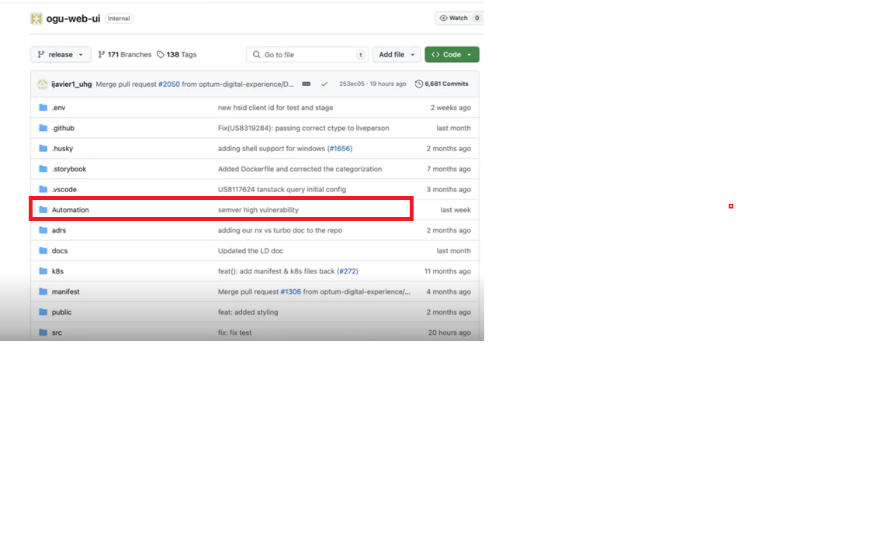

Open the VS Code terminal and go to the folder where your project is saved on your computer.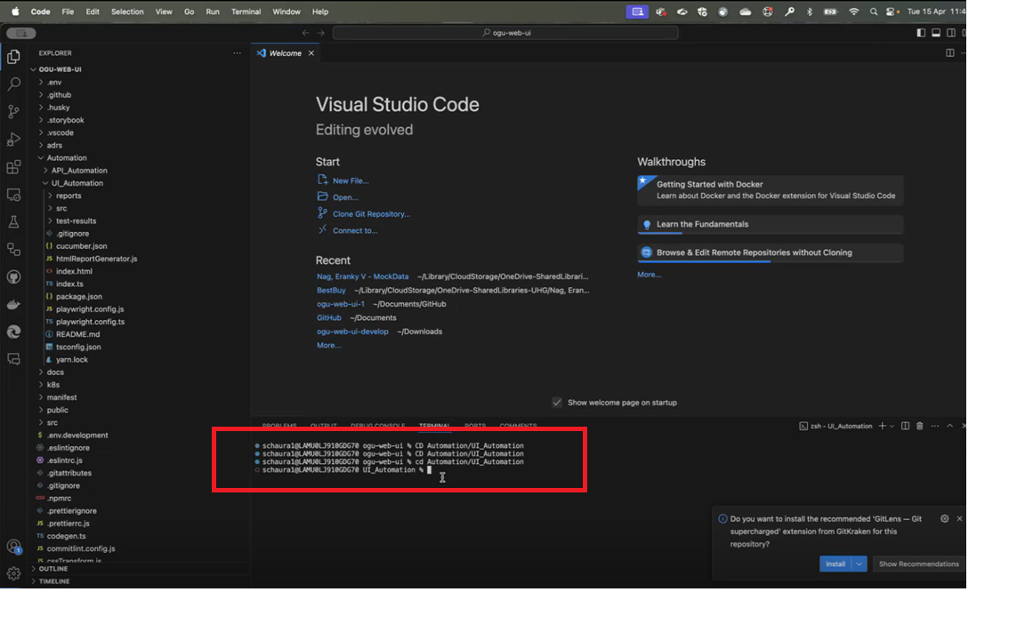

**Run the below commands in terminal:**

1.Yarn Install

2.Yarn add playwright

3.yarn add cucumber

4.yarn add axe-core

**Understand the Structure of the project:**

**Folder Structure:**

* Under test/features: All the feature files are located here.
* Under test/pages: This directory contains all the locators.
* Under test/steps: You'll find the step definition logic here.
* In the root UI-Automation folder: We have the cucumber.json file, which specifies the path to execute the feature files.

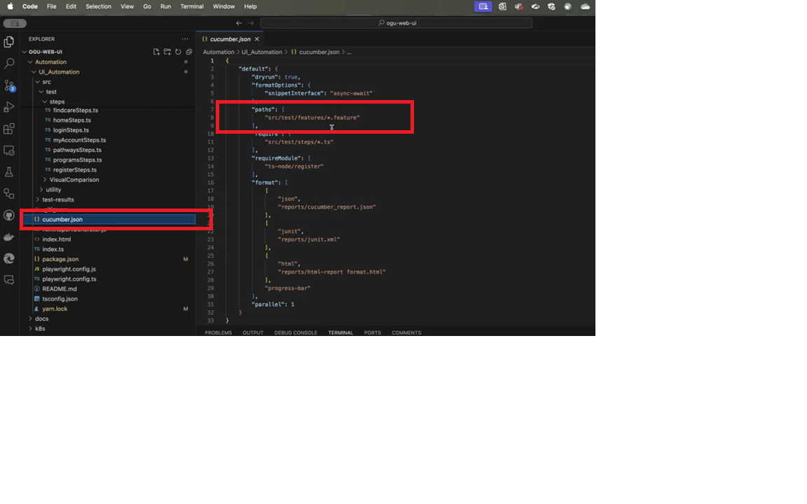

* Within the Automation → UI_Automation → src-env directory, you'll find the environment files used for configuring the environment settings."

* We have an env.ts file to manage and call the environment variables.

* Within the resources folder, we have the test data and user data.  
  And The package.json file is used to execute the script in a specific environment.

* Install the Cucumber extension from the VS Code marketplace to enable support for feature files.

* To run the script in the staging or any other environment, use the following command:  
  For example: yarn run test-stage."



Above command will execute all the feature files in the staging environment

* Within the hooks/types folder, we have the env.d.ts and hooks.ts files, which are used to define the browsers.

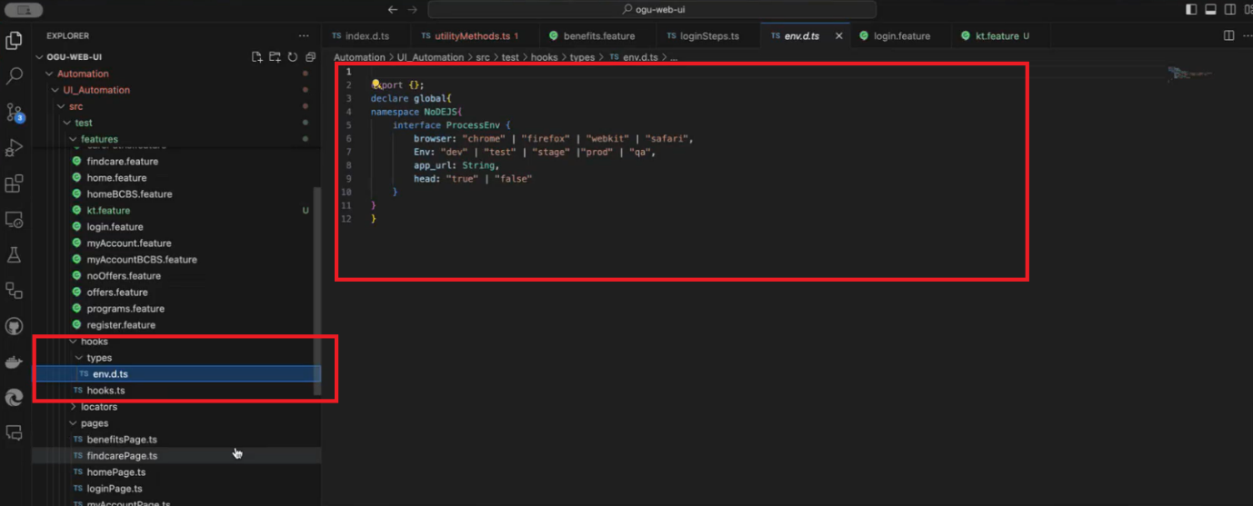

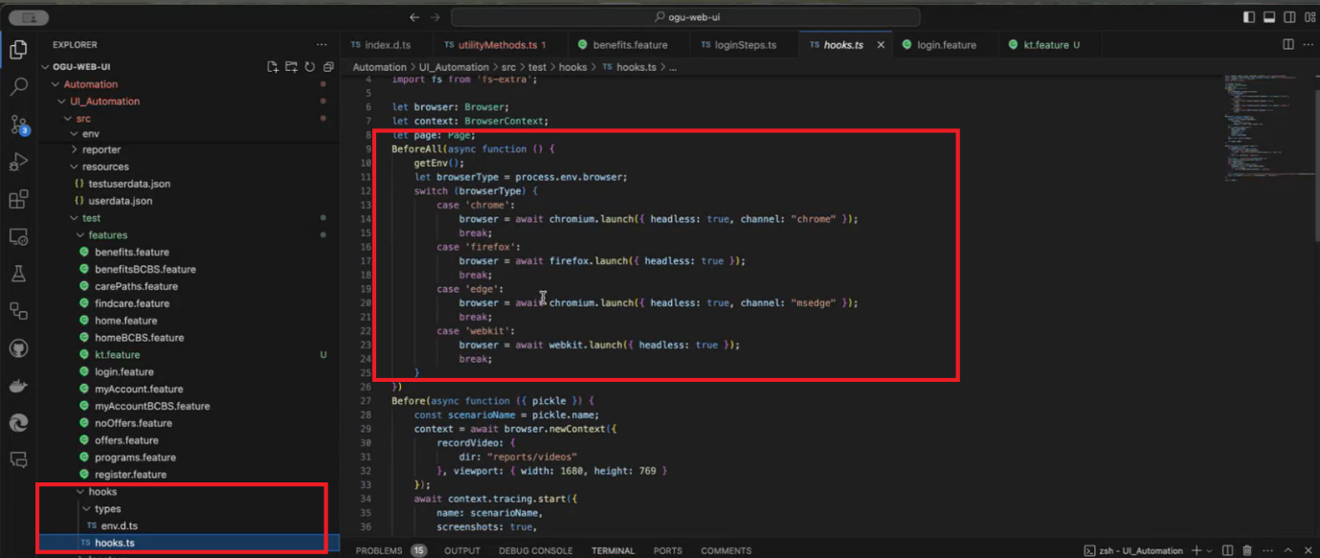

**To avoid the undefined lines in the code**

Got to settings as shown below in the screenshot

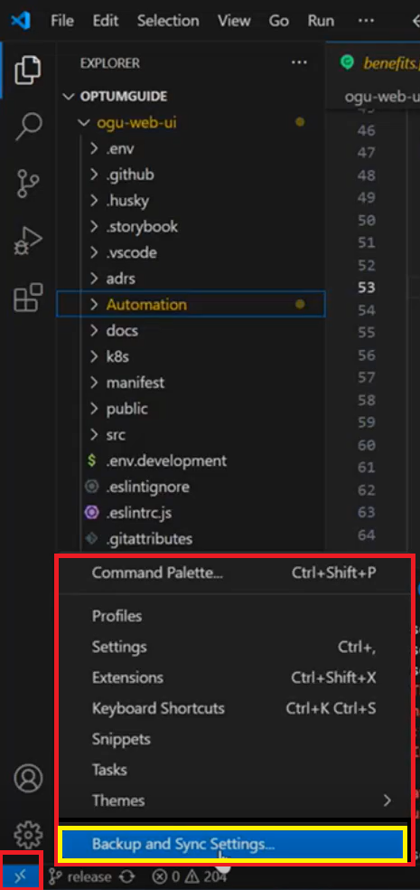

Search for 'Cucumber' in the settings file, click on 'Edit in settings.json', and then set the relative path of the feature file as:

Automation/UI_Automation/src/test/features/*.feature

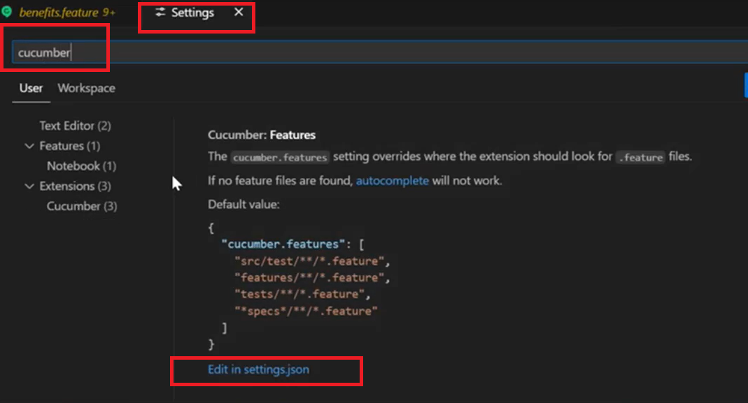

Next, search for cucumber-glue and set the relative path of the steps folder as follows:"

"Automation/UI_Automation/src/test/steps/*.ts"

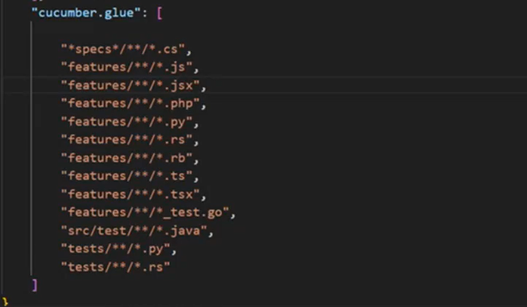

**PR Guidelines:**

Format: UserStoryNumber: Brief description of the PR.

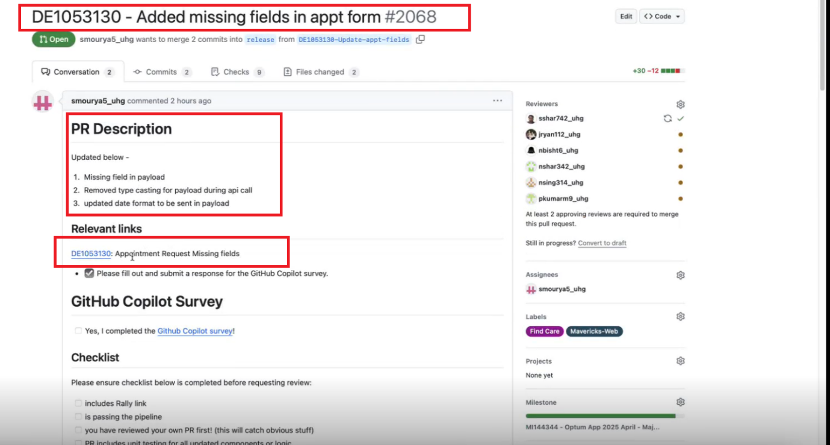

**Rally Project Access:**

First go to the following link: <https://secure.uhc.com/>

Then select the option à Application

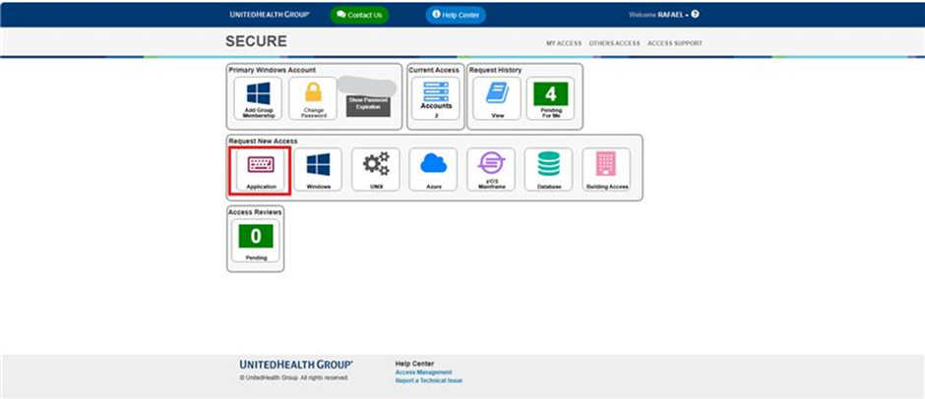Then search for “Rally” in the label under Application and select the option with the name RALLY

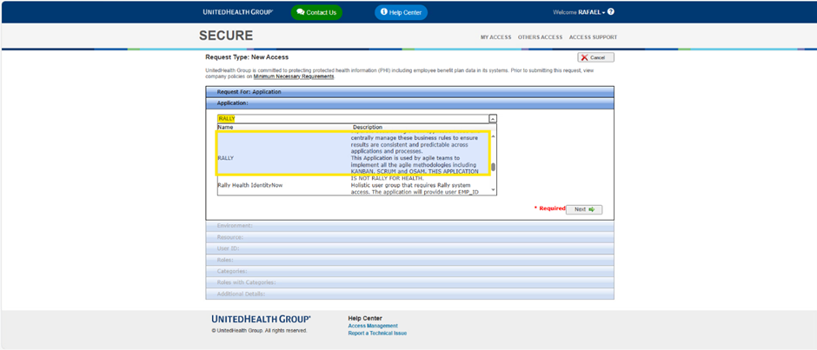

Click the button Next.

After that, select the option Create New User ID (If your User ID it's not visible)à Your User ID it's going to update à Click Next.

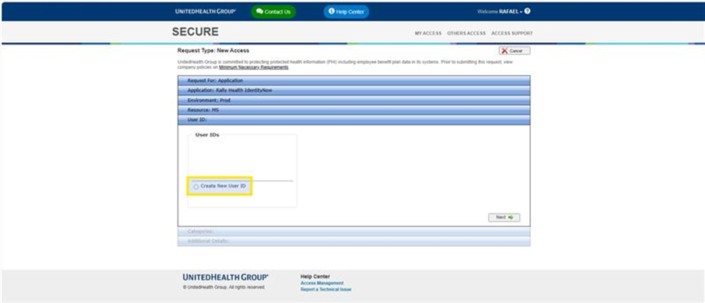

And provide the following information before submitting.

Role à workspace user

workspace à UHG

project à OHS Consumer Platform & Patient App

After submitting and after your request has been approved

To access the project, please navigate to the following link:

<https://atop.optum.com/RallyProjectAccess>

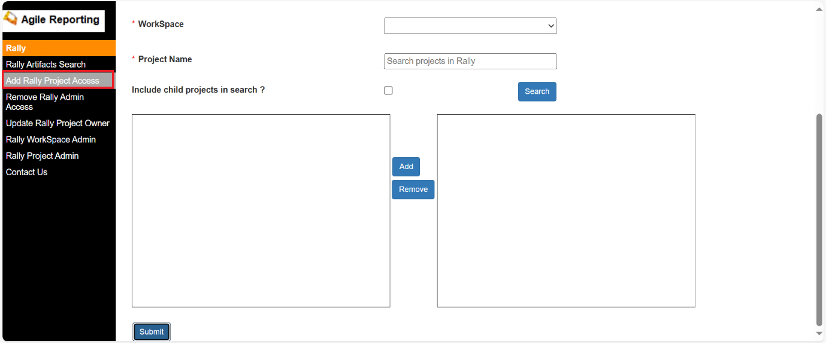

And provide the following information before submitting.

workspace - UHG

project - OHS Consumer Platform & Patient App

role- workspace user

